Curriculum Overview: Art Cycle A
Art at Corpus Christi Catholic Primary

“To be an artist is to believe in life” Henry Moore.

 | Painting | Drawing | Textiles | Modelling | Collage | Printing
Reception | 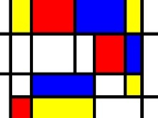  Mondrian | 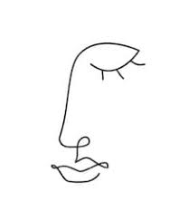 | 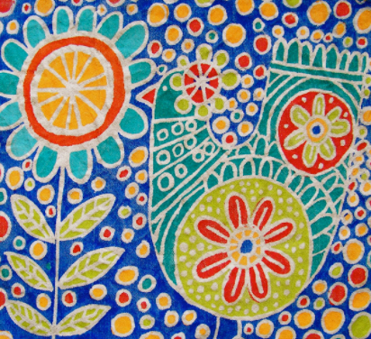  Batik | 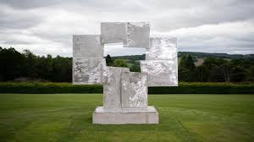  David smith – Yorkshire sculpture park | 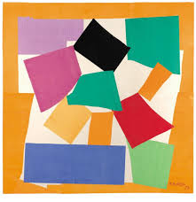  Matisse | 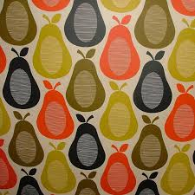  Orla Kiely
 | We are Painters  - Explores what happens when they mix colours  - Uses simple tools and techniques competently and appropriately. | We are draughtsmen  - Create simple representations of events, people and objects. | We are textile artists  - Understands that different media can be combined to create new effects  - Uses simple tools and techniques competently and appropriately | We are sculptors  - Understands that different media can be combined to create new effects  - Manipulates materials to achieve a planned effect.  - Constructs with a purpose in mind, using a variety of resources.  - Selects tools and techniques needed to shape, assemble and join materials they are using. | We are collage artists  - Understands that different media can be combined to create new effects  - Uses simple tools and techniques competently and appropriately | We are printers.  - Understands that different media can be combined to create new effects

 | Painting. | Printing | Modelling and sculpture |  | Collage | Textiles | Drawing
Year 1 | 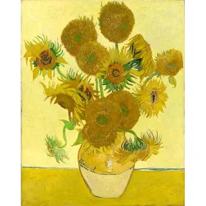  Van Gough | 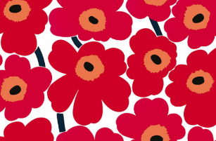  Marimekko | 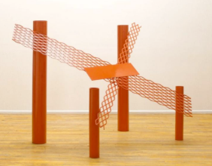  Anthony Caro | Year 2 | 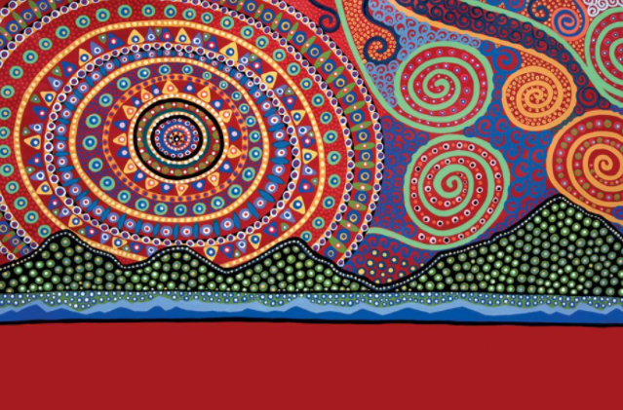  Bronwyn Bancroft | 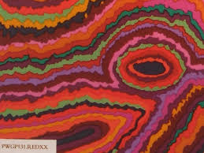  Kaffee Fassett | 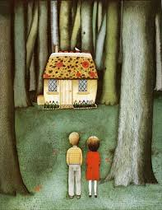  Anthony Browne (illustrator of Hansel and Gretel)
 | We are Painters  - Shades and tints  - Tools for paint application – different sized brushes  - Mix primary colours to make secondary  - Create colour wheels  - add black & white to make tints and tones | We are printers  - Rubbings  - Repeating pattern  - Block printing  - Mimic print from the environment eg wallpaper  - Press, rub, roll or stamp to make prints | We are sculptors  - Experiment with media  - Use a combination of shapes  - Impressions  - Junk modelling |  | We are collage artists  - Tearing & cutting  - Pattern & rotation  - Paper cutting  - Colour and texture  - Fold, crumple, tear and overlap | We are textile artists  - Weaving to create a pattern | We are draughtsmen  - Colour own work neatly, following the lines  - Use different pencils to draw lines of varying thickness and size.  - Add texture, use of dots and lines.  - Show tones by using coloured pencils
 |  |  | 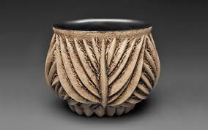  Chris Gryder  We are sculptors  - Clay: coil and pinch pots  - Use rolling, cutting and moulding techniques |  |  | 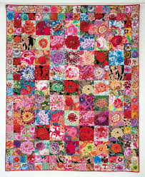  Kaffee Fassett  We are textile artists  - Patchwork using glue or a stich  - Dip- dying fabric

 | Painting. | Printing | Modelling and sculpture |  | Collage | Textiles | Drawing
Year 3 | 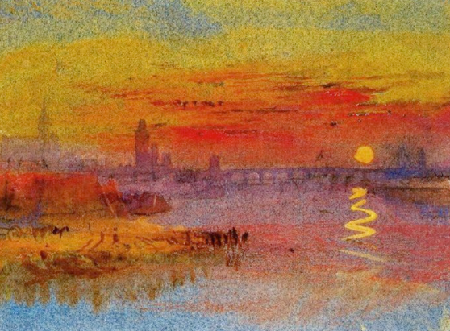  JMW Turner | 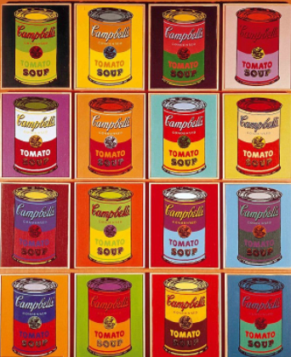Andy Warhol | 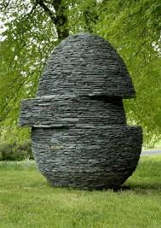  Andy Goldsworthy | Year 4 | 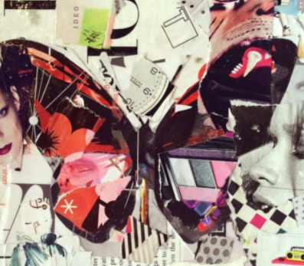  Derek Gores | 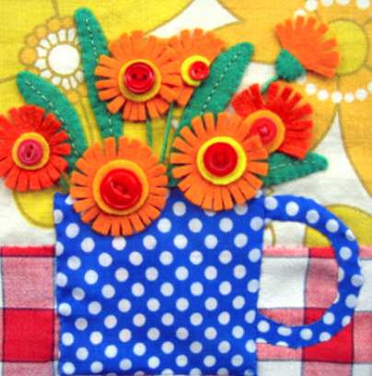 | 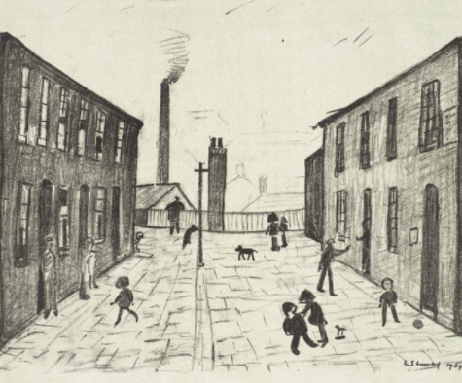L L S Lowry
 | We are painters  - Create a colour wheel  - Tertiary colours – mix colours effectively  - Use water colour to produce a back ground  - Experiment with creating mood with colour | We are printers  - Historical patterns  - Consolidate and combine previous techniques  - 2 colour print  - Press print | We are sculptors  - Create and combine shapes to create recognisable forms (eg shapes from a net or solid materials)  - Include texture to convey feelings  - Use clay/ papier mache or other mouldable materials  - Add materials to include interesting detail |  | We are collage artists  - Curling, pleating, scrumpling  - Ensure work is precise  - Contrasting colour | We are textile artists  - Pleating, padding, gathering  - Knitting/crochet  - Card weaving  - Embroidery stitches  - Joining fabric ends | We are draughtsmen  - Use different pencil grades  - Sketch lightly (no need for a rubber for mistakes)  - Annotate sketches to show and explain ideas  - Hatching and shading  - Use shading to show light and shadow

 | Painting. | Printing | Collage |  | Modelling and sculpture | Textiles | Drawing
Year 5 | Cezanne 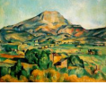 | 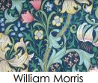  William Morris | 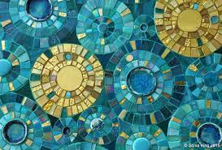Sonia King | Year 6 | 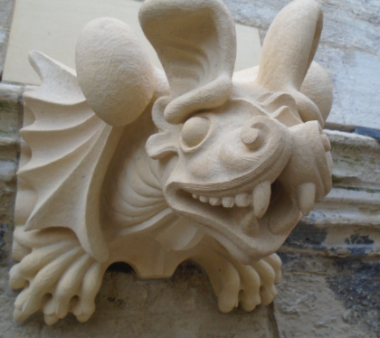  Tom Nichols | 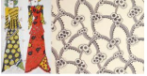  Celia Birtwell | 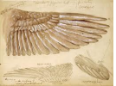Leonardo da Vinci
 | We are painters  - Sketch before painting  - Create own colour palette  - Use watercolour and/or acrylic  - Enhance the mood of a piece using colours, tones and tints  - Use brush techniques to create texture  - Develop a personal style while drawing on ideas from other artists | We are printers  - 3+ colour printing  - Create an accurate pattern  - Use a range of visual  - Elements to reflect the purpose of the work | We are collage artists  - Mix textures (rough and smooth, plain and patterned)  - Use ceramic mosaic materials and techniques |  | We are sculptors  - Use tools to carve and add shapes, texture and pattern  - Combine visual and tactile qualities  - Show life like proportions or, if more abstract, show different interpretations | We are textile artists  - Use a range of techniques and combine previous techniques to create pieces  - develop own designs | We are draughtsmen  - Use a variety of techniques to add effects (sunlight, shadow, reflections etc)  - Use lines to represent movement  - Use a choice of techniques to depict movement, perspective, shadows and reflection

