Curriculum Overview:
Computing at Corpus Christi Catholic Primary
At Corpus Christi we use the Purple Mash learning platform. Each year group covers an aspect of Digital Literacy, Information Technology and Computer Science.
 | Autumn 1 | Autumn 2 | Spring 1 | Spring 2 | Summer 1 | Summer 2
Reception | 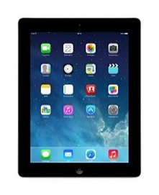 | 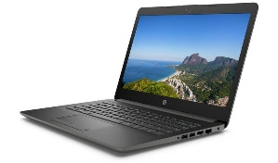 | 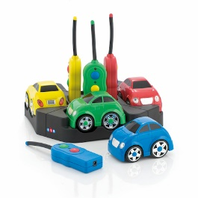 |  |  | 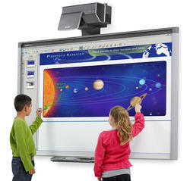
 | Children recognise that a range of technology is used in places such as homes and schools. They select and use technology for particular purposes.
Year 1 |  | 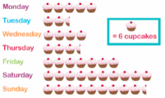 | 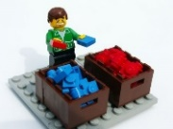 | 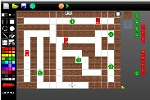 | 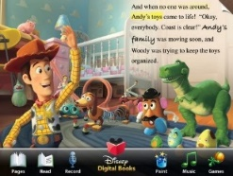
 | Unit 1.1- Online Safety (4 hours) | Unit 1.3- Pictograms  (3 hours) | Unit 1.4- Lego Builders (3 hours) | Unit 1.5- Maze Explorers (3 hours) | Unit 1.6-  Animated Story Books (5 hours) |  | Unit 1.7- Coding  (6 hours)
Year 2 |  |  | 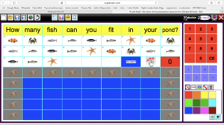 |  | 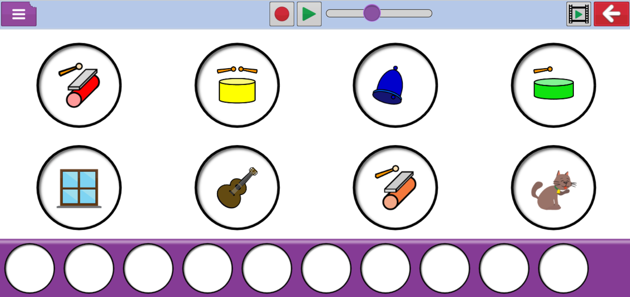 |  | 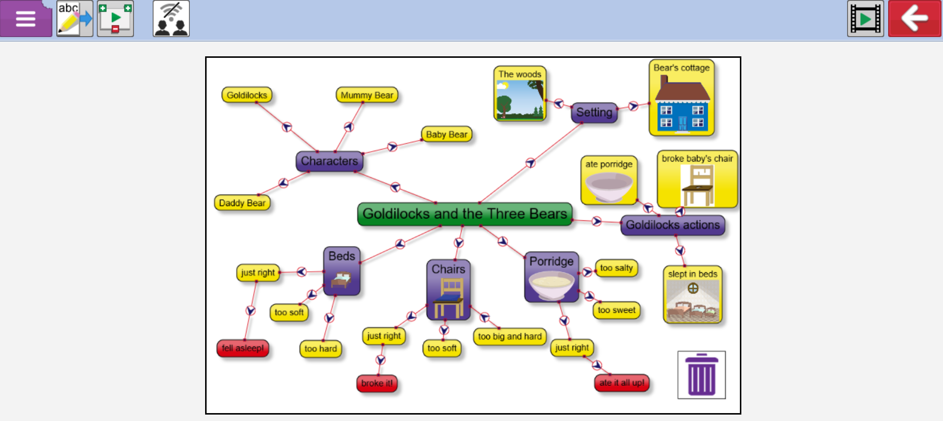
 | Unit 2.2- Online Safety  (2 hours) | Unit 2.1- Coding  (5 hours) | Unit 2.3- Spreadsheets  (4 hours) | Unit 2.5- Effective Searching  (3 hours) | Unit 2.7- Making Music  (3 hours) |  | Unit 2.8-Presenting Ideas  (4 hours)
 | Autumn 1 | Autumn 2 | Spring 1 | Spring 2 | Summer 1 |  | Summer 2
Year 3 |  |  | 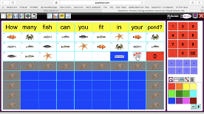 |  | 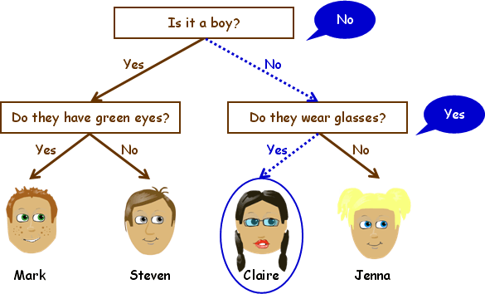
 | Unit 3.2- Online Safety  (2 hours) | Unit 3.1- Coding  (6 hours) | Unit 3.3- Spreadsheets  (3 hours) | Unit 3.5- Email  (6 hours) | Unit 3.6- Branching Databases  (4 hours) |  | Unit 3.7- Simulations  (3 hours)
Year 4 |  |  | 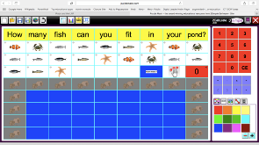 | 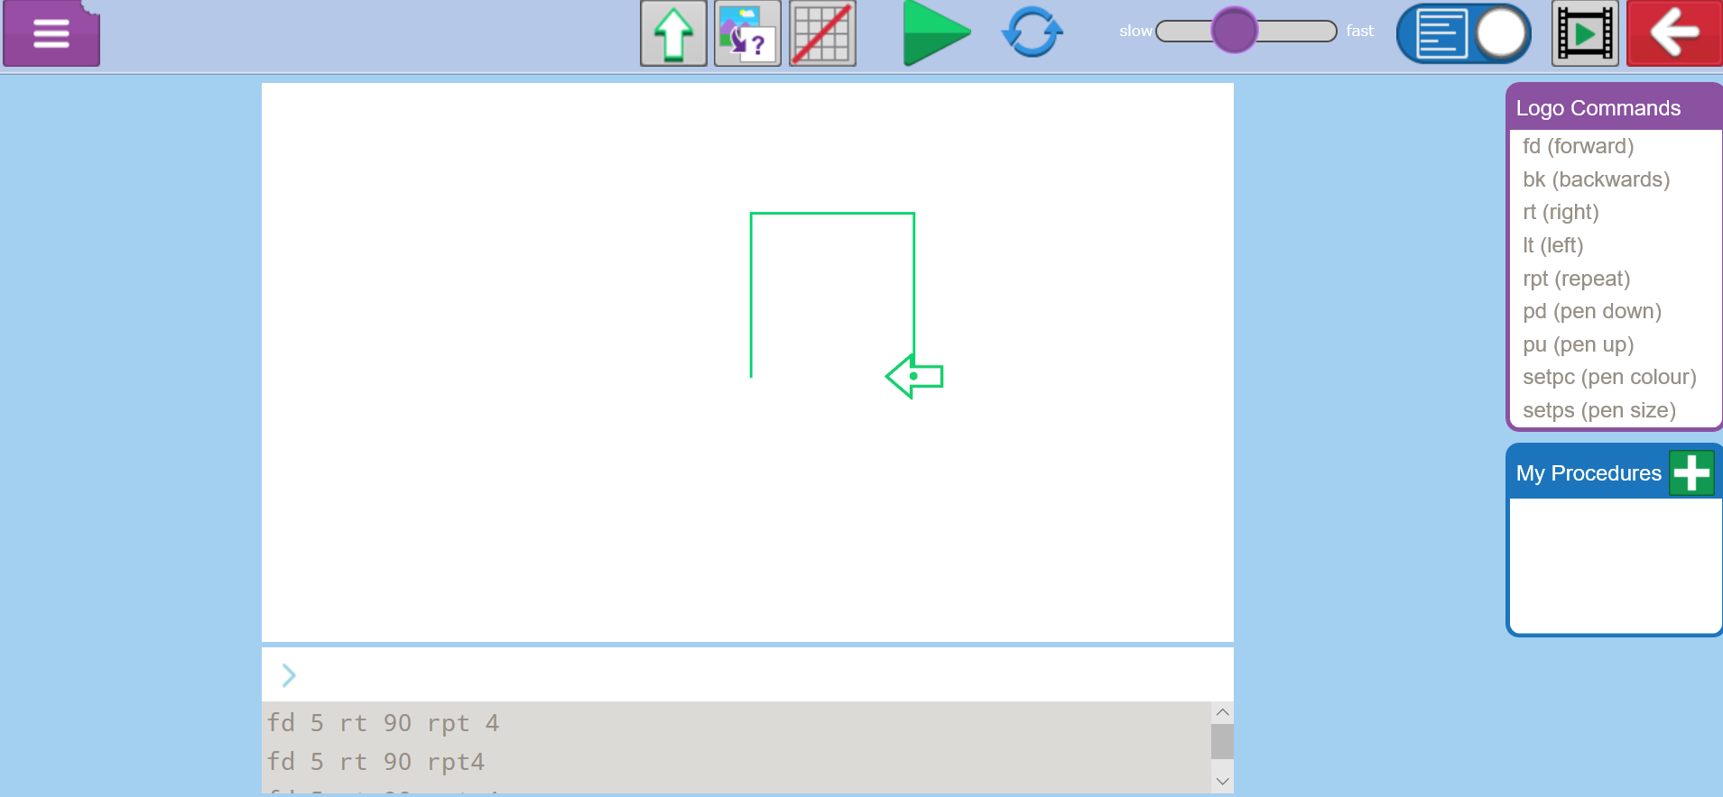 | 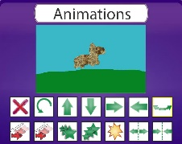
 | Unit 4.2- Online Safety  (2 hours) | Unit 4.1- Coding  (6 hours) | Unit 4.3- Spreadsheets  (6 hours) | Unit 4.5- Logo  (4 hours) | Unit 4.6- Animation  (3 hours) |  | Unit 4.7- Effective Search  (3 hours)

 | Autumn 1 | Autumn 2 | Spring 1 | Spring 2 | Summer 1 | Summer 2
Year 5 |  |  | 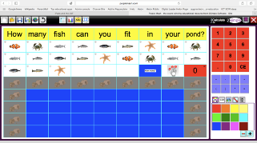 | 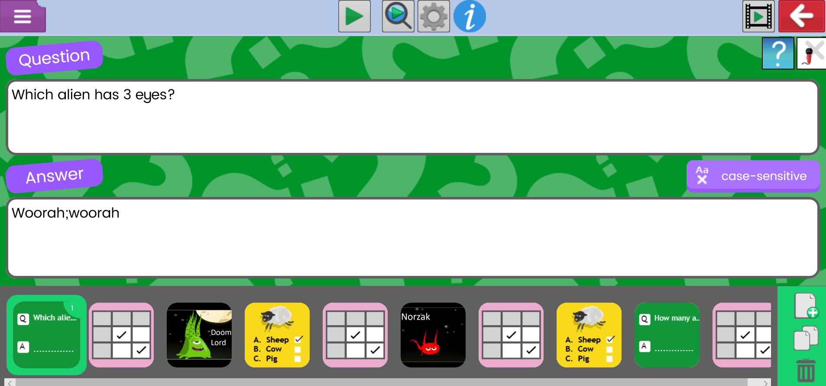 | 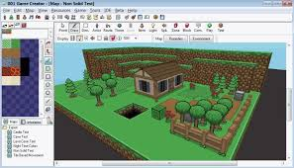 | 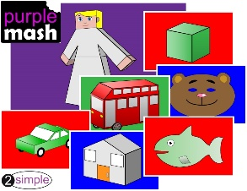
 | Unit 5.2- Online Safety  (2 hours) | Unit 5.1- Coding  (6 hours) | Unit 5.3- Spreadsheets  (6 hours) | Unit 5.4- Databases  (4 hours) | Unit 5.5- Game Creator (5 hours) | Unit 5.6- 3D Modelling (4 hours)
Year 6 |  |  | 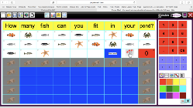 |  | 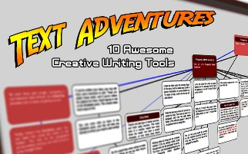
 | Unit 6.2- Online Safety  (2 hours) | Unit 6.1- Coding  (6 hours) | Unit 6.3- Spreadsheets  (5 hours) | Unit 6.4- Blogging  (5 hours) | Unit 6.5- Text Adventures  (5 hours) | Unit 6.6- Networks  (3 hours)

