Curriculum Overview: Writing 2019-2020
Writing is exciting!

Writing at Corpus Christi Catholic Primary
Reception |  | Autumn 1 |  | Autumn 2 | Spring 1 |  | Spring 2 |  | Summer 1 |  | Summer 2
Throughout the year children will be taught through shared and guided writing sessions.  This will include: early writing, name writing, lists, letters, cards and writing link to phonic activities.  Also CVC words (as soon as children have the necessary phoneme/ grapheme correspondence) and simple sentence writing |  | 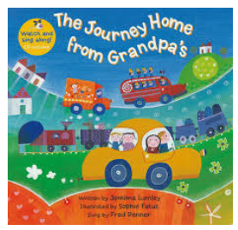 |  | 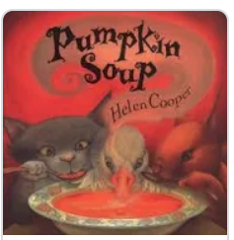 | 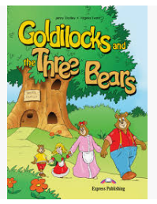 |  | 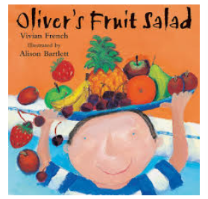 |  |  |  | 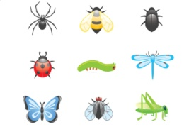
 |  | Early Writers  Mark making in various mediums: sand, shaving foam, chalking etc, including pencils for writing.  Features of a book.  Writing name. |  | Autumn  Correct formation of names, CVC words Phase 2, label writing  (vehicles) or caption. Lists, letters, cards. | Traditional Tales  Making their own narratives – story boards, sequencing, predictions. Independent sentence descriptions, adjectives, wow words and tricky words.  Phase 3 Phonics. |  | Write instructions for fruit salad  Writing their own instructions to make a fruit salad. Application of Phase 2 and 3 Phonics in writing, including tricky words.  Phase 3/4 Phonics. |  | Recount of a journey they have been on  Writing a recount of a school trip and journeys experienced.  . |  | Non- fictional writing  Instructions and facts about mini-beasts and habitats.
 | Autumn 1 |  | Autumn 2 |  |  | Spring 1 |  | Spring 2 |  | Summer 1 |  | Summer 2
Year 1  Year 1/2 | 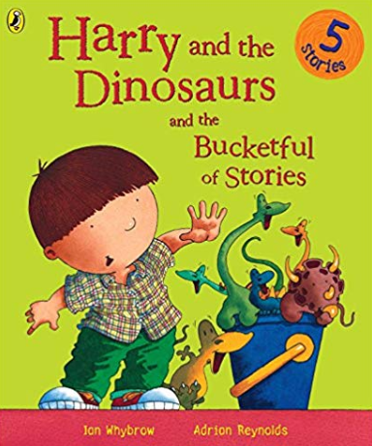 |  | 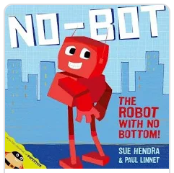 |  |  | 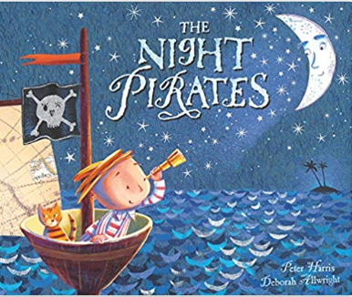 |  | 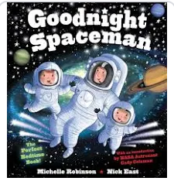 |  | 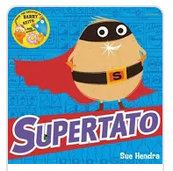 |  | 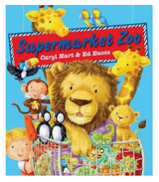
 | Non-fiction  Non-fiction texts, e.g. labels, lists, captions menus, invitations and postcards.  Non chronological reports. |  | Fiction  Narrative – No-Bot Robot  Poetry  All aboard the Toy Train |  |  | Fiction  Narrative - The Night Pirates  Non-fiction  Non chronological reports |  | Non-fiction  Narrative – Goodnight Spaceman  Non-fiction  Non-Chronological reports |  | Fiction  Fantasy Stories  Non-fiction  Instructions  Recount |  | Fiction  Supermarket Zoo, Alien School
Sentence and Text  Structure | Fact file - concept of a sentence, capital letters and full stops, word choices. |  | Retell known narrative – concept of a sentence, capital letters and full stops, word choices, correct past tense form. |  |  | Retell known narrative – concept of a sentence, capital letters and full stops, word choices, correct past tense form. |  | How words can combine to make sentences. |  | Sequencing sentences to form short narratives.  Recount an event/experience.  Instructions – numbered steps and verbs. |  | How to join words and sentences.

 | Autumn 1 | Autumn 2 | Spring 1 | Spring 2 | Summer 1 | Summer 2
Year 2 | 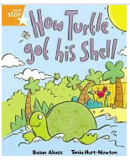 | 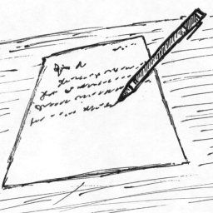 | 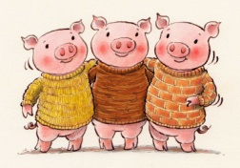 | 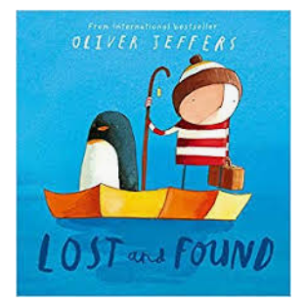 | 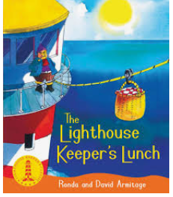 | 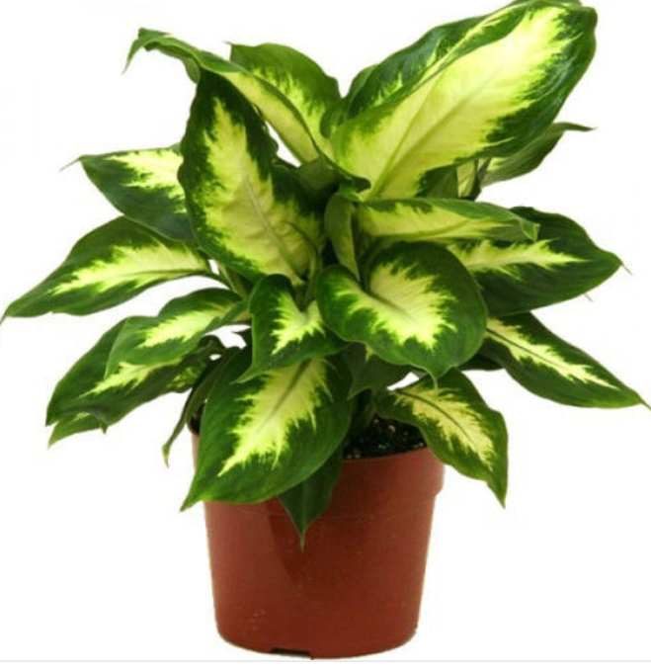
 | Fiction  Retelling stories and character description  Non-fiction  Recount, letters,  non-chronological report- London  Poetry  Autumn | Fiction  Fatou Fetch the Water story  Non-fiction  Letter linked to Florence Nightingale.  Instructions linked to Christmas decorations. | Fiction  Traditional Tales -Three Little Pigs  Non-fiction  Diaries and recount letters linked to Samuel Pepys  Newspaper report linked to The Great Fire of London | Fiction  Retell and create own story using inspiration from a short animation  Poetry  Faiths | Fiction  Retell and innovate  Non-fiction  Persuasion  Posters/letter to head teacher/ adverts | Non-fiction  Explanation - How plants grow/get water  Poetry  Summer
Sentence and Text Structure | Setting and character description from images and text – expanded noun phrases for description and specification.  Basic non-chronological report – present tense, opening question, concluding exclamatory sentence, subordination and coordination to join information or to give reasons, adverbs  Instructions – command sentences, commas in lists |  | Simple narratives – past tense, time adverbials to sequence events, adverbs to add detail.  Recounts – past tense, exclamatory sentence to make personal comment, subordination (when, if, that, or, because) and coordination (or, and, but) to join information or to give reasons, adverbs of time to sequence events. | Correct choice of consistent use of present tense verses past tense throughout texts.  Simple narratives – past tense, time adverbials to sequence events, adverbs to add detail. | Reading responses – conjunctions to join ideas or to give reasons  Explaining a process in sequence.  Description from images.  How grammatical patterns in sentences indicate its function as a statement, question, exclamation or command.  Use of the progressive form of verbs in the present and past tense to mark actions in progress (e.g. she is drumming, he was shouting).

 |  | Autumn 1 |  |  | Autumn 2 |  | Spring 1 |  | Spring 2 |  | Summer 1 |  | Summer 2
Year 3  Year 3/4  Year 4 |  | 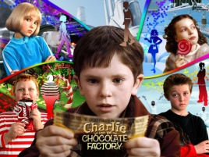 |  |  | 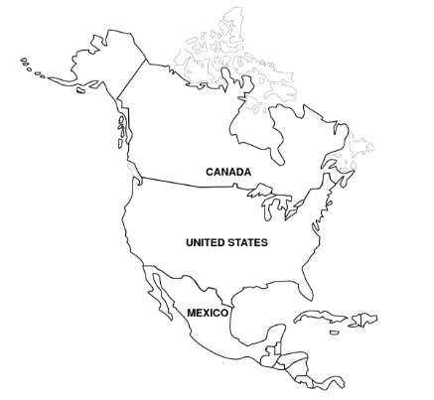 |  |  |  | 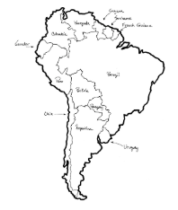 |  | 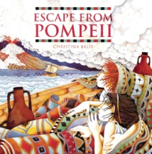 |  | 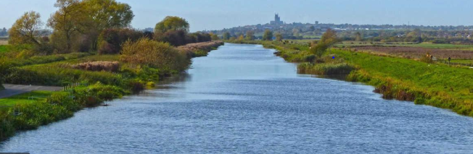
 |  | Non-fiction  Explanation Text – Charlie and the Chocolate Factory  Non-fiction  Biography – Roald Dahl |  |  | Non-fiction  Information Booklet- North America  Letters – Chris Mould (author)  Leeds Project  Poems with Figurative Language – Linked to Thanksgiving/ Christmas |  | Fiction  Greek Myths – Perseus and Medusa  Non-Fiction  Newspaper |  | Non-fiction  Reports including Formal Reports  Non-fiction  Persuasion  Debate  Poetry |  | Fiction  Novel as a Theme - Escape to Pompeii  Non-fiction  Recount diary entry – Linked to school trip |  | Fiction  Play Scripts and Film linked to school trip  Poems linked to Topic - Rivers
Sentence  and  Text  Structure |  | Explanation - sequential and causal language organised in paragraphs, fronted adverbials |  |  | Use of paragraphs to organise ideas around a theme. |  | Settings – expanded noun phrases  Description from images – possessive apostrophe  Characters - developed through dialogue and action |  | Recount and non-chronological report - organised in paragraphs  Persuasive advert or leaflet - expanded noun phrases, |  | Developed narrative - sequence organised into paragraphs using fronted adverbials to indicate changes in time or place. Dialogue to show character.  Noun phrases expanded by the addition of modifying adjectives, nouns and prepositional phrases. Appropriate choice of pronoun or noun within and across sentences to aid cohesion and avoid repetition.
 | Autumn 1 |  | Autumn 2 |  |  | Spring 1 |  | Spring 2 |  | Summer 1 |  | Summer 2
Year 5  Year 5/6  Year 6 | 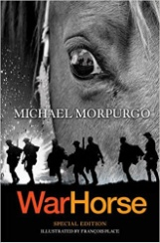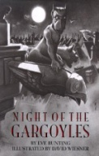 |  | 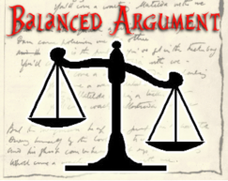 |  |  |  |  |  |  | 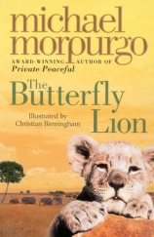
 | Poetry  Free verse - Night of the Gargolyes  Fiction  Novel as a theme  War Horse  Non-fiction  Balanced Argument |  | Non-fiction  Persuasion  Non-fiction  Explanation |  |  | Fiction  Older Literature  Oliver Twist  Non-fiction  Information Text |  | Non-fiction  Biography  Autobiography  Non-fiction  Explanation  Formal Writing |  | Fiction  Revising text types: Diary, Letter, Story, Non-chronological reports |  | Non-fiction  Leaver Booklets  Information texts
Sentence  and  Text  Structure | Texts with ideas and themes linked within and across paragraphs.  Linking ideas across  paragraphs using a wider range of cohesive devices: repetition of a word or phrase, grammatical  connections (e.g. the use of adverbials such as, on the other hand, in contrast, or as a consequence), and ellipsis. |  |  | Discussion writing – adverbials for cohesion, modal verbs and adverbs to position the argument.  Developed texts with clear voice and sustained register and well-rounded ending.  Journalistic writing – passive voice, shifts from formal to informal.  Use of the passive voice to affect the presentation of information in a sentence (e.g. I broke the window in the greenhouse versus The window in the greenhouse was broken (by me)). |  |  |  | Explanation – adverbials for cohesion, cause and effect language.  Narrative - atmosphere and mood created through effective word choice, sentence structure and literary devices, shifts in formality.  Report writing – passive voice, formality.  The difference between structures typical of informal speech and structures appropriate for formal speech and writing (such as the use of question tags, e.g. He’s your friend, isn’t he?, or the use of the subjunctive in some very formal writing and speech. |  |  |  | Information texts - layout devices, such as  headings, sub-headings,  columns, bullets, or tables, to structure text.

