**Glossary**

**Conjunction** – a word to join ideas within the same sentence.

For example: and, but, or, so, when, if, whilst, after, before etc)

**Exclamation mark** - An exclamation mark comes at the end of an exclamation. It shows that something is being exclaimed, or said with a lot of feeling. For example: I’m so late! Hurrah! It’s a goal! No! An exclamation mark can also come at the end of a command. For example: No! Run! Stop it!

**Genre** – text type

For example: mystery story, newspaper report, persuasive letter etc)

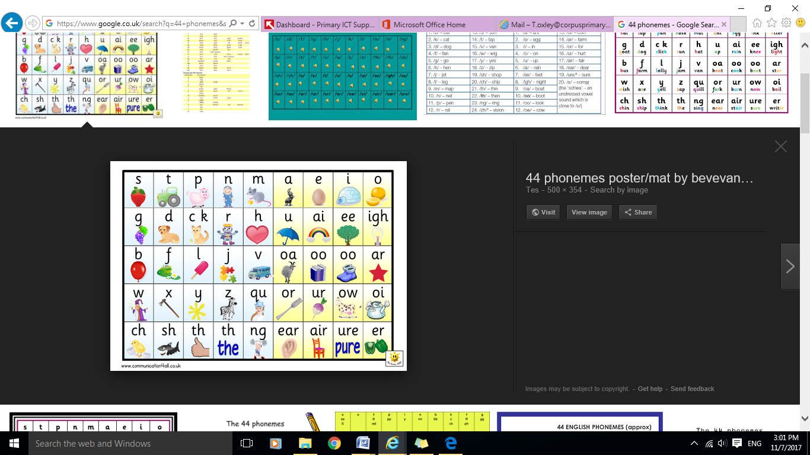**Grapheme** - written letters representing units of sounds

**Narrative** - story

**Phoneme** – unit of sound in a word

**Singular -** The singular of a noun is used when there is only one.

**Verb** – doing word

.**Joined Handwriting**

Children should sit correctly at a table, holding a pencil comfortably and correctly.

They should begin to form lower case letters in the correct direction, understanding which letters belong to which handwriting families, and forms capital letters and digits 0-9.

[](https://www.google.co.uk/url?sa=i&rct=j&q=&esrc=s&source=images&cd=&cad=rja&uact=8&ved=&url=https://www.canstockphoto.com/illustration/handwriting.html&psig=AOvVaw0xkoOjreohZSEGuj2qwW8B&ust=1510154249530097)

**Phonemes**

Spell words containing each of the 40+ phonemes.

**Year 1 Expectations of Spelling, Punctuation, Grammar and Handwriting**

________________________________



**Before children leave Year 1 they should be able to...**

**Spelling**

Spell common exception words and days of the week.

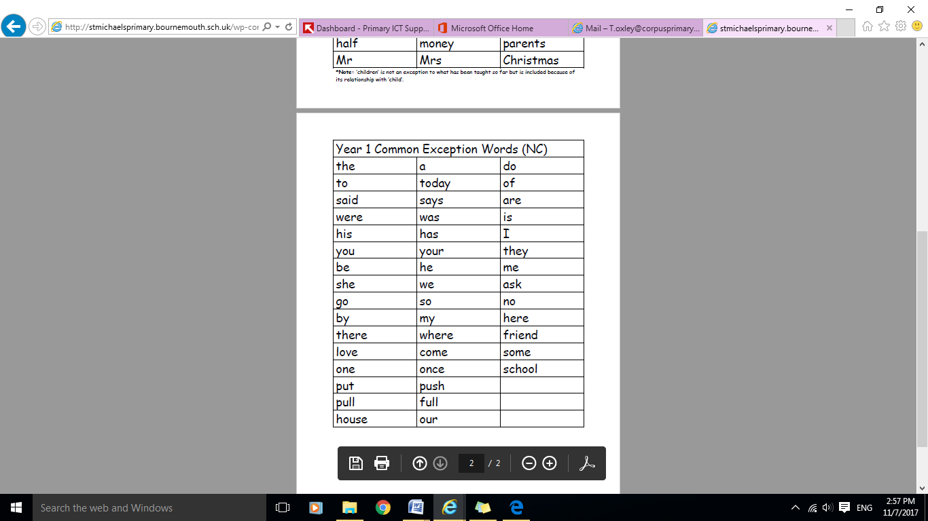

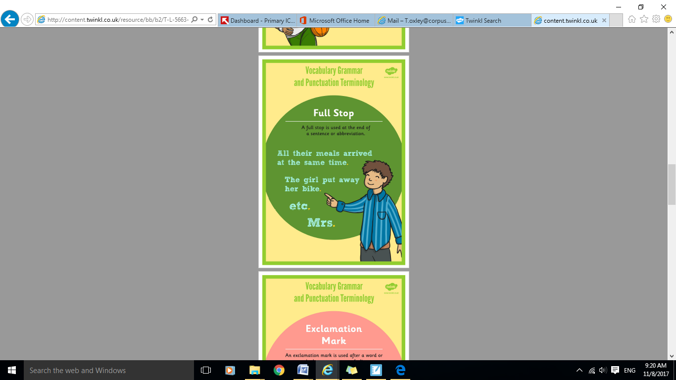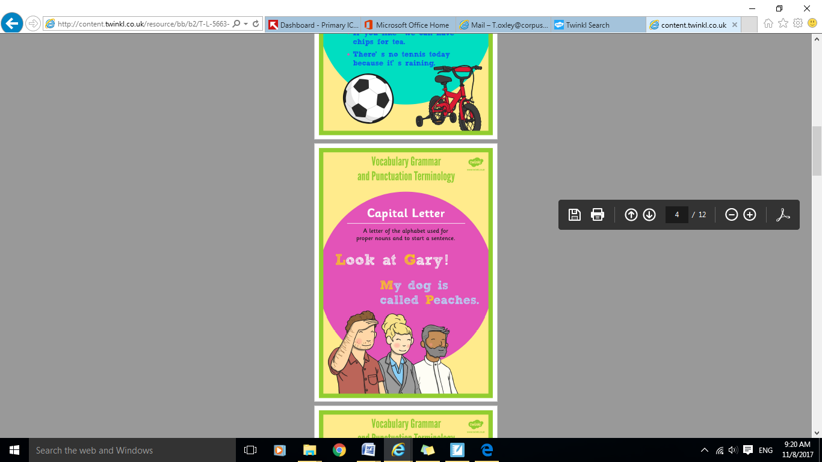

**Alphabet**

Name the letters of the alphabet in order and uses letter names to distinguish between alternative spellings of the same sound.

[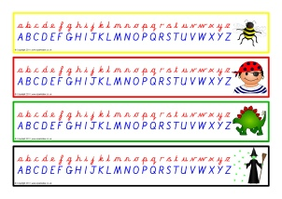](http://www.google.co.uk/url?sa=i&rct=j&q=&esrc=s&source=images&cd=&cad=rja&uact=8&ved=&url=http://www.sparklebox.co.uk/cll/alphabet/mats.html&psig=AOvVaw1tHidqFKPF-gAgsVDKda88&ust=1510154391333976)

**Suffixes and Prefixes**

Use and understand plural noun suffixes –s and –es

For example: dog, dogs, wish, wishes.

Know that suffixes can be added to verbs.

For example: helping, helped, helper.

How the prefix un– changes the meaning of verbs and adjectives

For example: unkind or undoing.

**Ways to help your child**

Ways to help your child

Practise using common words in sentences out loud and written down. Ensure children understand the meaning of the words they are using.

**Punctuation**

Separate words with spaces.

Use capital letter for: names, places, days of week and personal pronoun I.

Begin to use capital letters, full stops, question marks and exclamation marks in sentences.

**Grammar**

Know words combine to make sentences and can sequence sentences to form short narratives.

Join words and clauses using and.

