**Glossary**

**homophone** - words that sound the same but have different spellings

**expanded noun phrase -** description (adjective / adverb) that changes the meaning of the noun

**fronted adverbials -** adverbs of time, place and manner that appear at the beginning of sentences (e.g. **Quickly**, Mrs Robbins leapt to her feet. )

**Inflectio**n - the name for the way a word changes to indicate tense, number

* **eat/eats/ ate/eating/eaten**
* **fast/faster/fastest**

**progressive form (tense)** - a progressive action—leading up to the present (I **have** been waiting for this bus for half an hour.)

.

**Joined Handwriting**

* Use continuous cursive.
* Down strokes of letters are parallel and equidistant and lines of writing are sufficiently spaced so that ascenders and descenders do not touch.

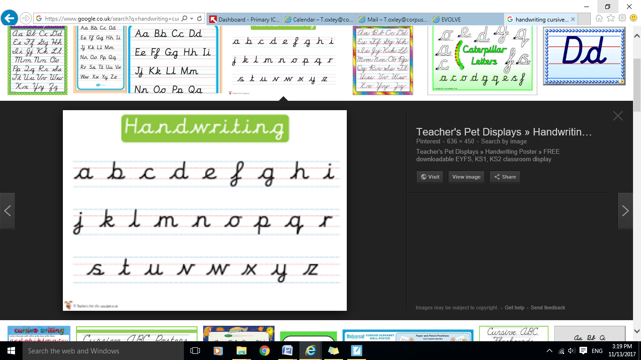

**Ways to help your child:**

* Read stories and talk about what makes them good. Encourage children to use literary language from books.

**Year 4 Expectations of Spelling, Punctuation, Grammar and Handwriting**

______________________________________



**Before children leave year 4 they should be able to...**

**Spelling**

* Spell all of the commonly misspelt words

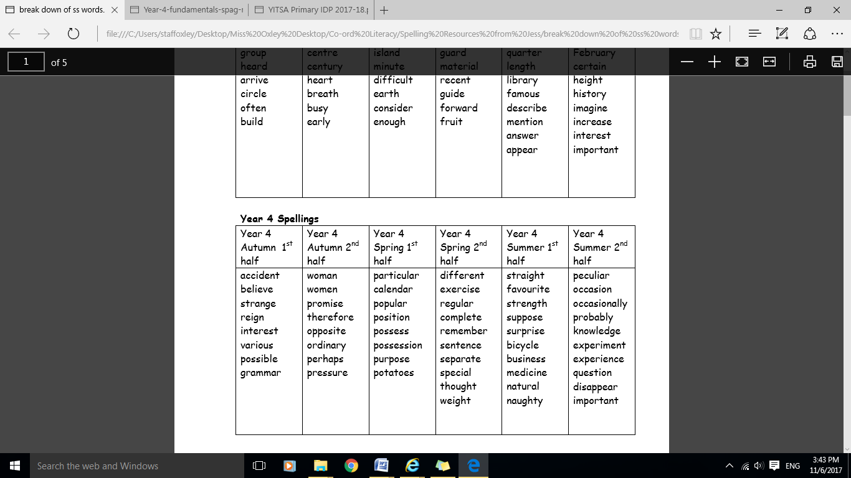



* Spell words with ch, -gue/-que, sc (with Greek, French & Latin roots) and words with the sound spelt ei, eigh or ey.

**Homophones and near homophones**

* Accurately use homophones and near homophones knowing the difference in meaning

[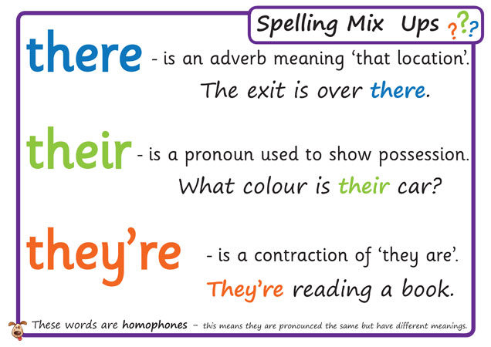](http://www.google.co.uk/url?sa=i&rct=j&q=&esrc=s&source=images&cd=&cad=rja&uact=8&ved=&url=http://displays.tpet.co.uk/?resource=1024&psig=AOvVaw1tDGYEk8yAo8p2fQrsKc8i&ust=1510672467376807)

**Suffixes and Prefixes**

* Use and understand prefixes before root words starting with l, m, p or r & prefixes: re-, sub-, inter-, super-, anti-, auto– and use and spell suffixes which end –ion and – ian (spelt –tion, -sion, -ssion, -cian)

**Punctuation**

* Use inverted commas and other punctuation to indicate direct speech.

**Grammar**

* Use present perfect form of verbs.
* Expand noun phrases by adding modifying adjectives, nouns and preposition phrases.
* Use fronted adverbials followed by commas.
* 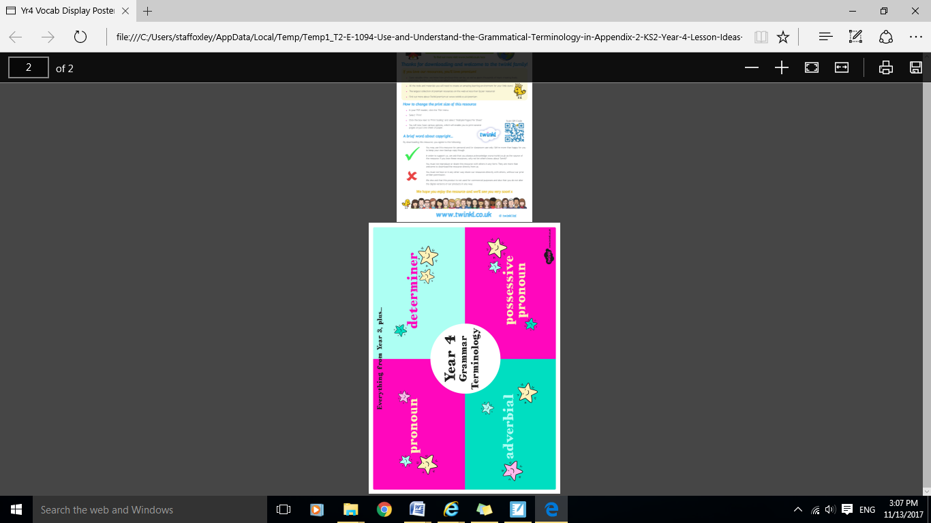Use standard English forms of verb inflections rather than local spoken forms.