**Glossary**

**Homophone:** Words that sound the same but have different meaning.

For example: their/there/they’re or heard/herd

**Modal Verbs:** helper verbs that support the main verb by expressing additional information**.**

For example: can/could, may/might, must, will/would, shall/should)

**Parenthesis**: Parenthesis is a word, phrase or sentence that is put in writing as extra information or afterthought. If you took the parenthesis away, the passage would still be complete without it.

For example: Italy – a country in Europe – is beautiful in summer.

**Perfect Form:** an action that has happened in the past but has consequences in the present. For example: I **have** been to school.

**Relative clause:** Modifies a noun using relative pronouns by adding additional information.

For example: The cow, which was spotty, lay down in the field.

**Relative pronoun:** which, that, who, whom, whose

**Joined Handwriting**

* Use continuous cursive writing
* Write legibly, fluently and with increasing speed

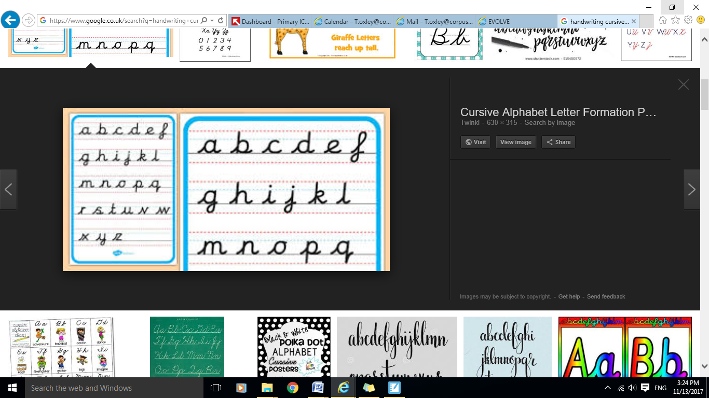

**Ways to help your child:**

* 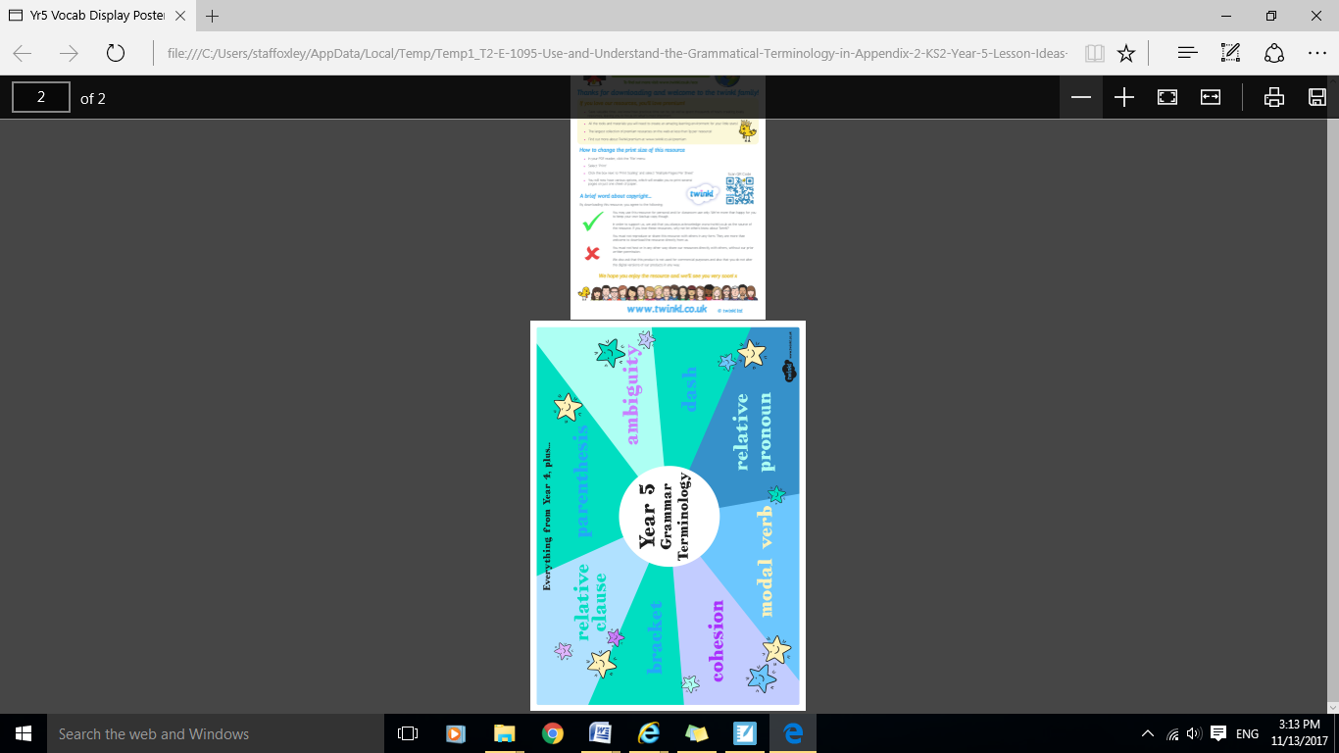Encourage children to add additional information using relative pronouns – who, which, that, whose etc when describing characters or people.

**Year 5 Expectations of Spelling, Punctuation, Grammar and Handwriting**

______________________________________



**Before children leave year 5 they should be able to...**

**Spelling**

* Spell all of the commonly misspelt words

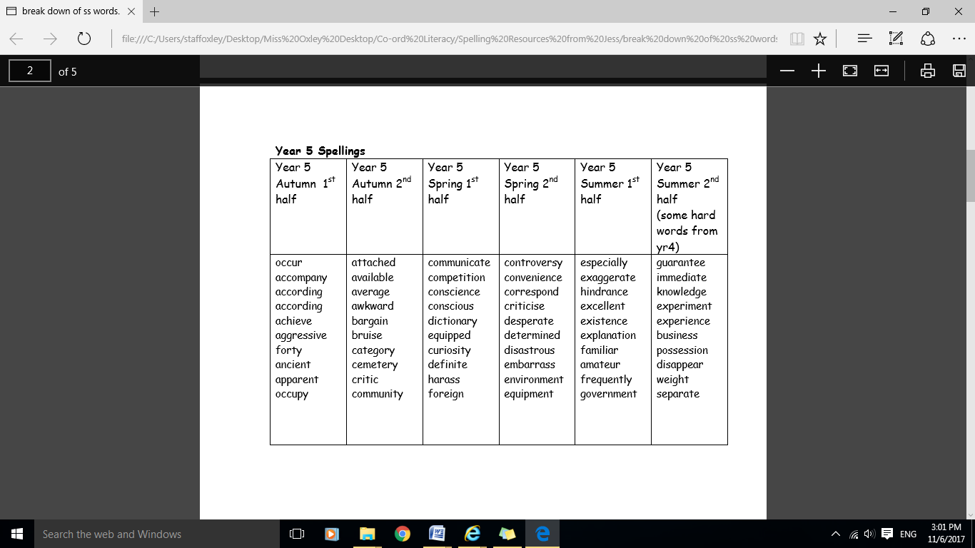

**Suffixes and Prefixes**

Use and understand suffixes:

* –cious or –tious
* –cial and –tial.
* -ant, -ance or –ancy
* -ent, -ence, -emcy

Use and understand prefixes:

* dis-
* de-
* mis-
* over-
* re-

**Terminology**

* modal verb
* relative clause
* relative pronoun
* parenthesis
* brackets
* dash
* cohesion
* ambiguity

**Punctuation**

* Use brackets, dashes and commas to indicate parenthesis.
* Use commas to clarify meaning or avoid ambiguity

**Grammar**

* Use the perfect form of verbs to mark relationships o time and cause.
* Use modal verbs or adverbs to indicate degrees or possibility.
* Use relative clauses with a relative pronoun.
* Use relative clauses with an implied (i.e. omitted) relative pronoun.
* Convert nouns or adjectives into verbs using suffixes (-ate, -ise, -ify)
* Use verb prefixes dis-, de-, mis-, over-, re-)