**Glossary**

**Active Voice:** In a sentence with an active verb, the subject of the verb is doing the action. This is called the active voice.

For example: Hilda strode into the goal area.

**Passive Voice:** In a passive sentence, the subject of the verb is the one that has something done to it, so the do-er disappears or is mentioned after ‘by’.

For example: The ball was caught by the girl.

**Subject:** The subject of a verb is often who or what does or is something (the do-er or be-er). In a statement, the subject is usually the noun, noun phrase or pronoun just before the verb.

For example: The bird pecked the apple.

**Object**: The object of a verb is who or what is acted upon by the verb. In a statement, the object is usually the noun (or noun phrase or pronoun) just after the verb. For example: The bird pecked the apple.

**Synonym:** words that mean the same – or nearly the same – as each other, such as *big* and *huge*, or *horrible* and *nasty*. For example: They lived in a big house. They lived in an enormous house.

**Antonym:** Words that mean the opposite of each other, such as wet and dry, full and empty, open and closed.

**Joined Handwriting**

* Maintaining legibility, fluency and speed in handwriting

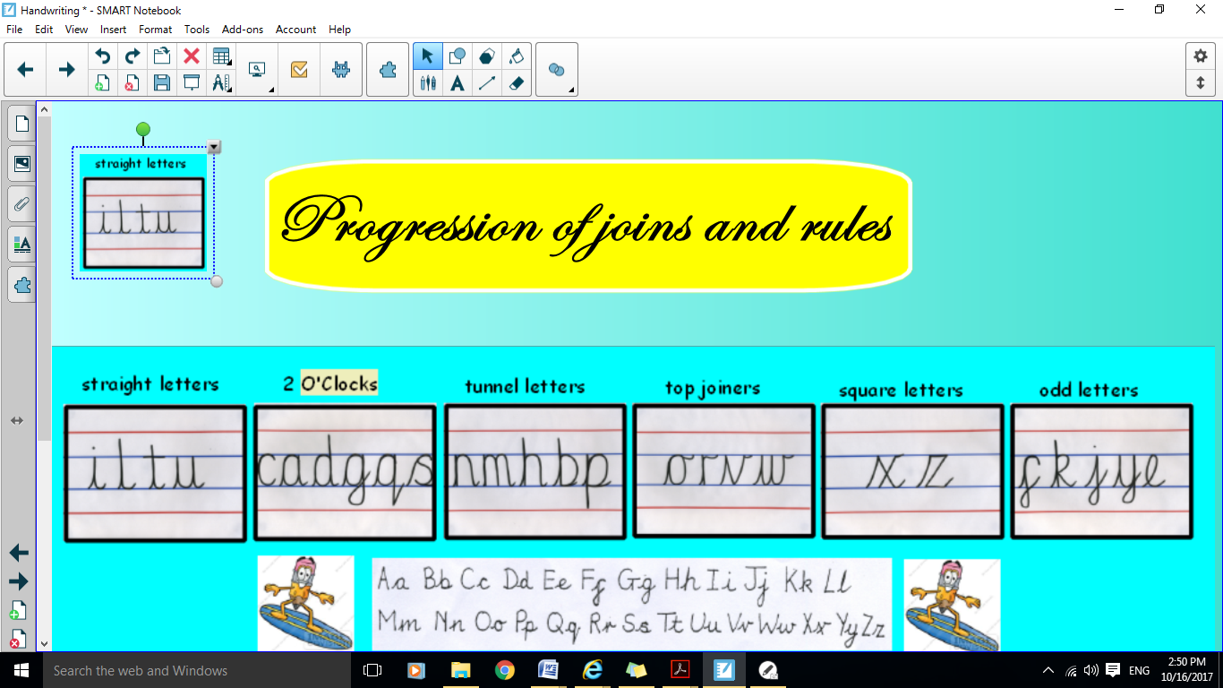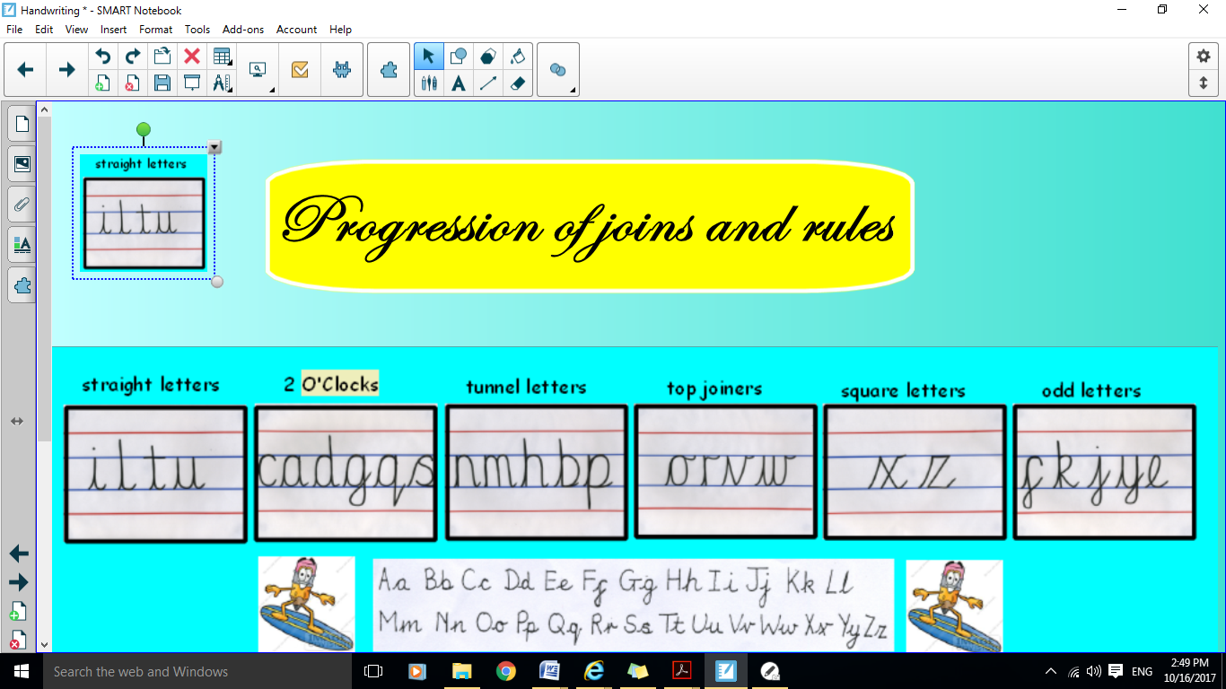





**Ways to help your child:**

* Encourage children to discuss the effect of punctuation when reading. Can they use it in their own writing?
* Read online using ‘Active Learn’ and complete the activities
* Weekly spelling
* Library book

**Year 6 Expectations of Spelling, Punctuation, Grammar and Handwriting**

______________________________________



**Before children leave year 6 they should be able to...**

**Spelling**

* Spell all of the commonly misspelt words

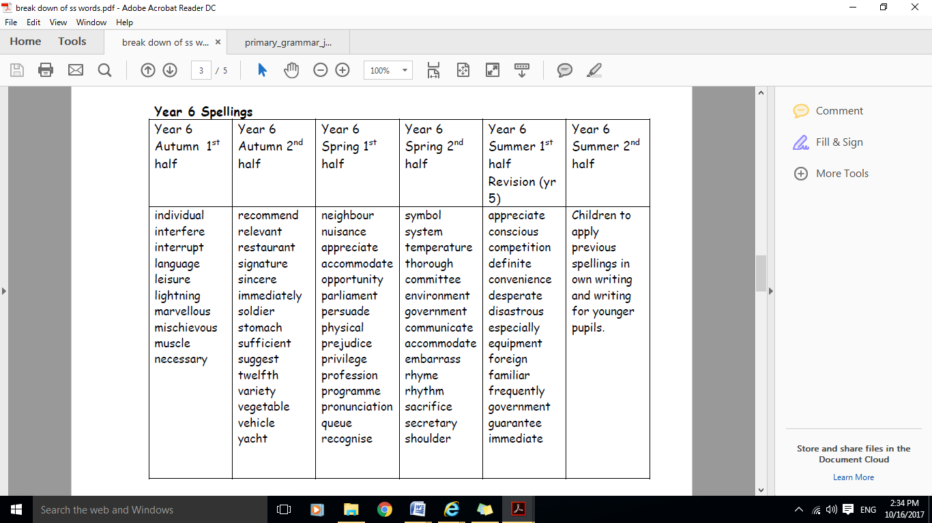



**Homophones**

• Accurately uses homophones and near homophones knowing the difference in meaning.

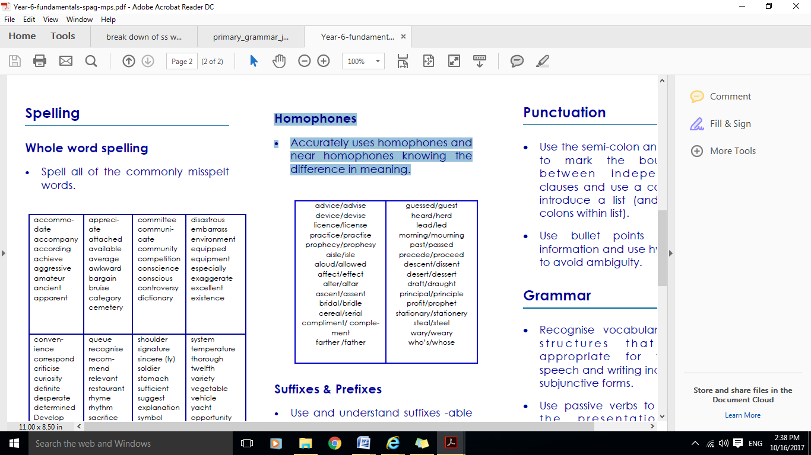

**Suffixes and Prefixes**

* Use and understand suffixes -able or -ible and -ably or -ibly and add suffixes beginning with vowel let-ters for words ending in –fer.
* Use a hyphen to join a prefix to a root word.

**Punctuation**

* Use the semi-colon and dash to mark the boundary between independent clauses (For example: It’s raining; I’m fed up.)
* Use a colon to introduce a list
* Use bullet points to list information

* Use hyphens (For example: man-eating shark)

**Grammar**

* Subject
* Object
* Active
* passive
* Synonym
* Antonym
* Ellipsis
* Hyphen
* Colon
* Semi-colon