Curriculum Overview: Design Technology
Design Technology at Corpus Christi Catholic Primary
In each year group, pupils will develop their skills in the five areas of food, textiles, construction, models and graphics. Teachers are free to teach these at any point in the year so as to link to learning in other curricular areas. Pupils are taught to explore and develop their ideas as well as to evaluate their work to see how it could be improved.
 | Food | Textiles | Construction | Models | Graphics/CAD
Year 1 | 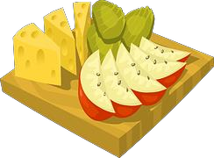 | 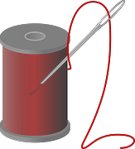 | 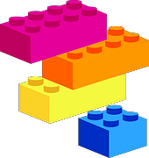 | 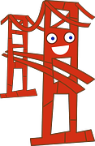
 | We are chefs  - Food vocabulary  - Grate and cut  - Measure and weigh | We are tailors  - Fabric paints, tie-dye  - Create own templates  - Join using running stitch and over sewing | We are product designers  - Construction kits  - Wheels with axles  - Cut using a template | We are model makers  - Fold, tear and cut  - Roll paper to form tubes  - Hinges  - Investigate strengthening sheet materials | We are graphic designers  - Use a stencil to create a print  - Repeat the print accurately creating a pattern
Year 2 | 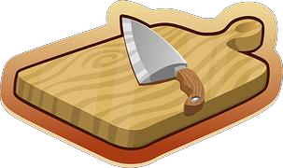 | 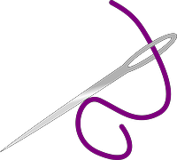 | 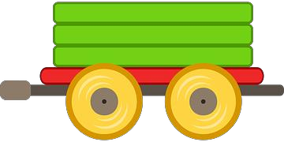 | 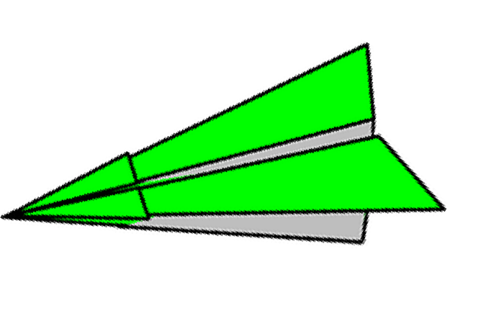 | 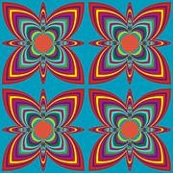
 | We are chefs  - Food vocabulary  - Grate and cut  - Measure and weigh | We are tailors  - Fabric paints, tie-dye  - Create own templates  - Join using running stitch and over sewing | We are product designers  - Models with wheels  - Use hacksaw and bench hook | We are model makers  - Curl paper  - Hinges  - Pop-ups  - Investigate joinings | We are graphic designers  - Print repeating pattern  - Use paint package to create repeated pattern

 | Food | Textiles | Construction | Models | Graphics/CAD
Year 3 | 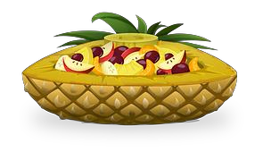 |  | 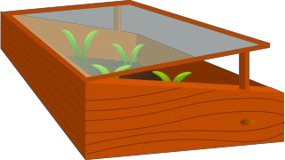 | 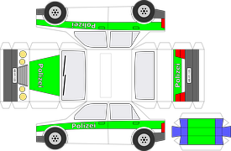 | 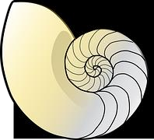
 | We are chefs  - Follow instructions  - Healthy choices  - Combine a range of ingredients | We are tailors  - Seam allowance  - Back stitch  - Sew on buttons and make loops  - Glued applique | We are product designers  - Shell or frame structures  - Measure and mark to the nearest 1cm  - Use glue gun with close supervision | We are model makers  - Cut slots  - Cut internal shapes  - Create nets | We are graphic designers  - Research a product  - Use CAD software
Year 4 | 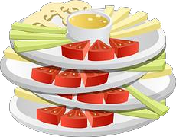 | 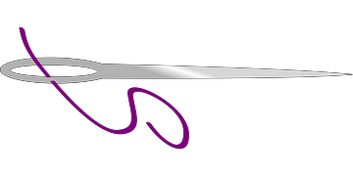 | 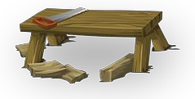 | 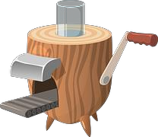 | 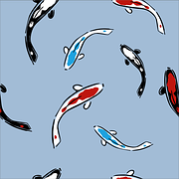
 | We are chefs  - Follow instructions  - Healthy choices  - Combine a range of ingredients | We are tailors  - Make a prototype  - Stitched applique  - Create a pattern | We are product designers  - Shell or frame structures  - Measure and mark to the nearest 1cm  - Use glue gun with close supervision | We are model makers  - Levers and linkages  - Complex pop ups | We are graphic designers  - Create and print a product design  - Use software to create a repeating pattern

 | Food | Textiles | Construction | Models | Graphics/CAD
Year 5 | 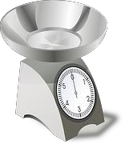 |  | 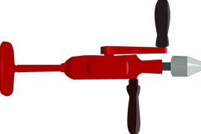 | 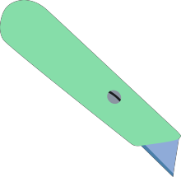 | 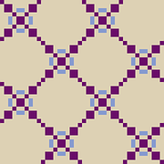
 | We are chefs  - Use scales  - Beat, rub in  - Decorate food | We are tailors  - 3D products  - Pin and tack  - Blanket stitch | We are product designers  - Use a bradawl  - Hand drilling  - Accuracy to 1mm  - motors | We are model makers  - Cut safely and accurately  - Use a craft knife  - Choose appropriate sheet materials | We are graphic designers  - Computer generated geometric designs  (link to Maths)
Year 6 | 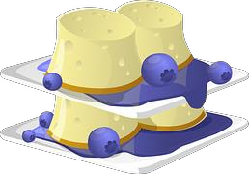 | 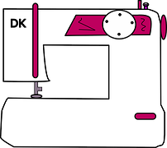 | 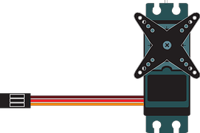
 | We are chefs  - Use scales  - Beat, rub in  - Decorate food | We are tailors  - Machine stitching  - Combine fabrics  - Produce quality products | We are product designers  - Include a motor and switch  - Use an ICT control program  - build frameworks | We are model makers  - Cut safely and accurately  - Use a craft knife  - Choose appropriate sheet materials | We are graphic designers  - Model ideas on computer  - Plan sequence of work on storyboard  - Use an ICT control program

