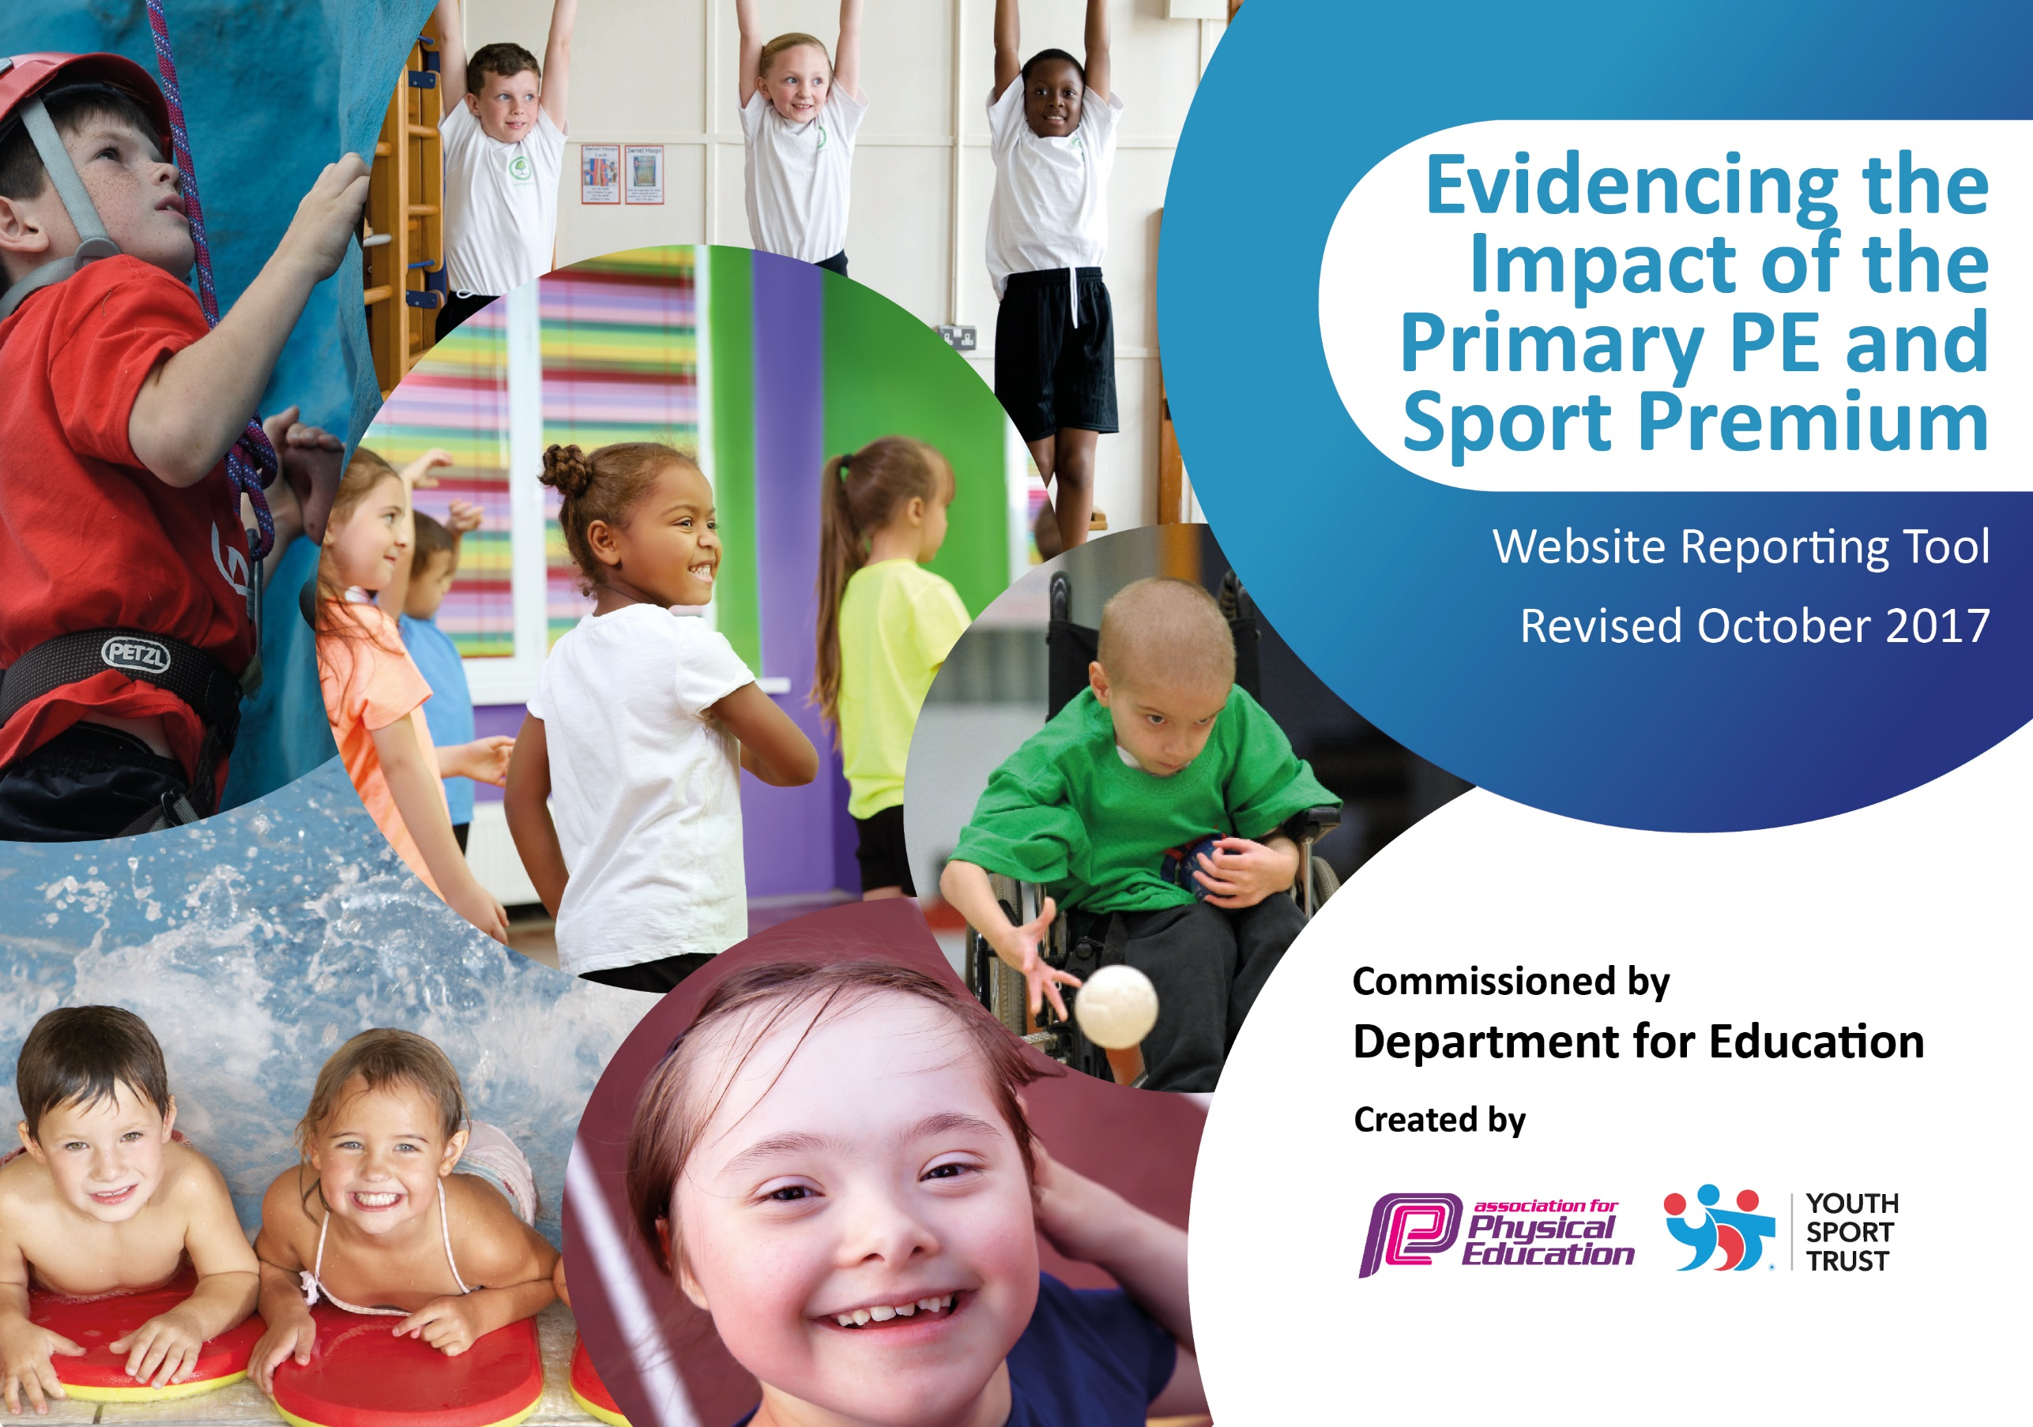

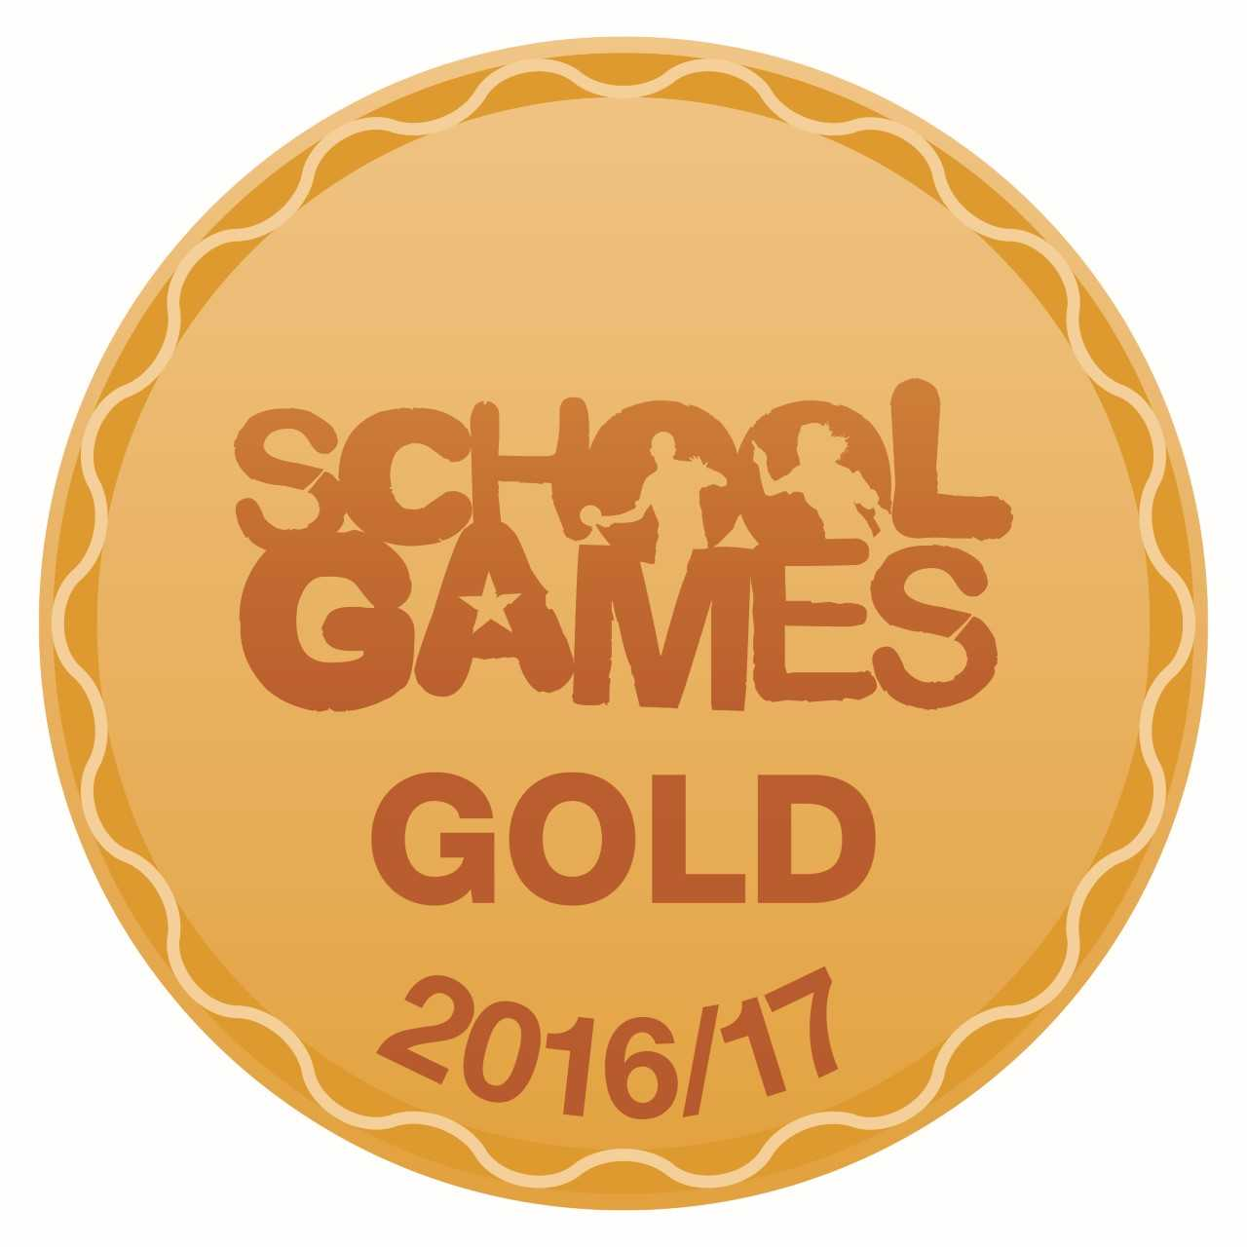

In September 2017 we achieved the Gold School Games Mark award for our commitment, engagement and delivery of competitive school sport in 2016/17.
Evidencing the Impact of the Primary PE and Sports Premium 2017-2018
at
Corpus Christi Catholic Primary School
Swimming and water safety is an extremely important part of the PE curriculum at Corpus Christi Catholic Primary School and is another way of helping children to lead healthy and active lives. Throughout the academic year, pupils in Y4 attend swimming lessons. We also provide opportunities, later in the year, for pupils in Year 5 & 6 pupils who have not met the national curriculum requirements.

Pupils are grouped according to their ability and are taught to:
- Swim competently, confidently and proficiently over a distance of at least 25 metres
- Use a range of strokes effectively (for example, front crawl, backstroke and breaststroke)
- Perform safe self-rescue in different water-based situations.

End of Key Stage 2 Data 2017/18
Swimmers 25m and over | 46 | 90%
Non Swimmers | 1 | 2%
Pupils who can use a range of strokes | 49 | 96%
Pupils who can perform safe self-rescue in different water-based situation | 50 | 98%
Schools can choose to use the Primary PE and Sport Premium to provide additional provision for swimming but this must be for activity over and above the national curriculum requirements. Have you used it in this way? | Yes

Sports Premium Spending Breakdown 2017-2018

Key indicator 3 | Increased confidence, knowledge and skills of all staff in teaching PE and sport | Leeds Rhinos Foundation | £8000
 |  | Leeds United Foundation | £1000
Key indicator 1 | The engagement of all pupils in regular physical activity – Chief Medical Officer guidelines recommend that primary school children undertake at least 30 minutes of physical activity a day in school | Playground Markings | £5000
 |  | PE equipment £1000 | £1000
Key indicator 2 | The profile of PE and sport being raised across the school as a tool for whole school improvement | Active Schools | £1000
 |  | Swimming | £1000
Key indicator 4 | Broader experience of a range of sports and activities offered to all pupils | COPAMO Academy | £2400
 |  | White Rose Cheer | £1000
Key indicator 5 | Increased participation in competitive sport | TNLP Competition Partnership SLA | £500
 |  | Transport | £1000
 |  |  | Total Spending £21, 900

S
Action Plan and Budget Tracking
Capture your intended annual spend against the 5 key indicators. Clarify the success criteria and evidence of impact that you intend to measure to evaluate for students today and for the future.

Academic Year: 2017-2018 | Total fund allocated: £18,000 | Date Updated: 2.11.2017
Key indicator 1: The engagement of all pupils in regular physical activity – Chief Medical Officer guidelines recommend that primary school children undertake at least 30 minutes of physical activity a day in school |  |  |  | Amount and percentage of total allocation:
 |  |  |  | £7000 (39%)
School focus with clarity on intended impact on pupils: | Actions to achieve: | Funding allocated: | Evidence and impact: | Sustainability and suggested next steps:
To embed the engagement of pupils in regular physical activity during the school day | Develop markings on the playground and additional playground/PE equipment in consultation with pupils via the Sports and PE Council  New partnership with the Leeds United Foundation and Premier League Primary Stars.  Additional Lunchtime clubs on offer with the Leeds Rhinos Foundation  After school sports clubs available each day | Playground marking £5000  As part of Leeds United Foundation cost £500  As part of  Leeds Rhinos Foundation  £1500 | Children have had the opportunity to access at least 30 minutes a day regular activity through lunchtime and after school clubs on offer.  Increased percentage of pupils participating in lunch time clubs.  Lunchtime clubs- Leeds Rhinos  Y1 – Multiskills  Y2 – Skipping & Sports Hall Athletics  Y3 – Skipping & Sports Hall Athletics  Y4 – Tennis / Athletics  Y5 – Sportshall Athletics | Physical activity through extra-curricular clubs, including lunchtime clubs, are embedded within the school day with some led by existing teaching staff.  Pupils have had increased opportunities to participate in extra-curricular sports activities through lunchtime and after school clubs.
Key indicator 2: The profile of PE and sport being raised across the school as a tool for whole school improvement |  |  |  | Amount and percentage of total allocation:
 |  |  |  | £2000 (11%)
School focus with clarity on intended impact on pupils: | Actions to achieve: | Funding allocated: | Evidence and impact: | Sustainability and suggested next steps:
To continue to raise the profile of school sport.  To increase additional PE opportunities for Pupil premium and SEND pupils. | Ensure that we remain part  of the Active Schools  programme and access  a range of the activities on offer  Ensure that there are a wide range of activities for pupils to participate in both within school and in local competitions  Maintain a good balance of sports on offer and increase that to include new sporting opportunities including:  - Cheer dance  - Tennis  - Goalball  - Copamo football clubs three times per week  Increased percentage of pupils participating in lunch time clubs. | £1000  See Key Indicator 4 for costings | Data analysis shows that as a school we are performing well above national standards especially by the end of Key Stage 2.  http://www.corpusprimaryleeds.org/our-school/key-school-info/2016-results  To create links with local clubs and sign post children to sports club. | Continue to ensure that the aspirations and ambitions of all our pupils are as high as possible by ensuring they are the best version of themselves through modelling ‘Excellence and Enjoyment with Christ at our Centre’  We maintained our high pupil outcomes at the end of the academic year 2017-2018
To provide additional swimming provision targeted to pupils not able to meet the swimming requirements of the national curriculum. | Trial extended swimming session for one class.  Pay for an additional swimming instructor  Pupils who are struggling to meet the national curriculum swimming requirements to attend inclusive Aqua Festivals to water boost confidence. | £1000 | Increase in percentage of children who can swim 25m using a range of strokes. | Increasing teacher to pupil ratio during swimming lessons which have a sustainable impact in the long term.  Increased percentage of pupils who can swim 25m  2018-2019 swimming lessons to be 1 hour in length

Key indicator 3: Increased confidence, knowledge and skills of all staff in teaching PE and sport |  |  |  | Amount and percentage of total allocation:
 |  |  |  | £9000 (50%)
School focus with clarity on intended  impact on pupils: | Actions to achieve: | Funding  allocated: | Evidence and impact: | Sustainability and suggested  next steps:
To provide staff with professional development, mentoring, training and resources to help them teach PE and sport more effectively  To increase teachers’ subject knowledge and confidence to teach high quality PE lessons through attendance on FA Primary Teachers Award and mentoring with Leeds Rhinos and Leeds United Foundations. | Links with the Leeds Rhinos Foundation for the third year. Increase number of days to two full days  New partnership with Leeds United Foundation and Premier League Primary Stars  Use a staff training day (February 2018) for teachers to attend FA Primary Teachers Award | £8000  £1000 | Staff have weekly CPD with experienced coaches.  Bespoke teaching plan for staff to follow.  Teachers attended Primary Teacher’s Award (FA Primary Stars initiative) to further deepen understanding of assessment and outcomes in PE | Existing staff and newly qualified staff have increased confidence to teach high quality PE lessons through weekly mentoring  Newly qualified staff and experienced teachers achieved Primary Teachers Award run by the FA which is certificated and supports assessment and curriculum subject knowledge.
Key indicator 4: Broader experience of a range of sports and activities offered to all pupils |  |  |  | Amount and percentage of total allocation:
 |  |  |  | £4,400 (22%)
School focus with clarity on intended  impact on pupils: | Actions to achieve: | Funding  allocated: | Evidence and impact: | Sustainability and suggested  next steps:
Additional achievements:  Increase non-traditional sport opportunities for pupils  Hire qualified sports coaches to work with teachers to enhance or extend current opportunities  Increase the percentage of Pupil Premium & SEND children attending inter school opportunities  Involve pupils in the decision making process for PE and Sports provision in school | Pupil Premium Focused Activities  - Cheerleading  - Golf  - Kurling  Continue to work with local clubs and sports coaches to enhance and extend current opportunities e.g COPAMO academy (3 after school clubs)  White Rose Cheer (1 after school cheerleading club)  Enter inclusive Active School’s activities;  Goalball  Aqua Festival  Archery  Inclusive Sports Hall Athletics.  Leeds Rhinos Foundation ( 2 after school clubs and 2 lunchtime clubs)  Hold regular PE and Sports Council meetings, involving pupils in decisions especially regarding playground markings | Cheerleading £1000  COPAMO  Football Academy  £2400  Transport costs  £1000  Total  £4,400  Governor Focus Group meetings | A range of ‘non-traditional’ sports on offer for all children.  Higher percentage of Pupil Premium participation and SEND children attending extra-curricular PE opportunities. | The new sports, dance and physical activities which were introduced during the academic year have encouraged more pupils to try sport and physical activities  Pupils attended extra football after school clubs and were given more opportunities to participate in football competitions  Extra opportunities provided for Pupil Premium and SEND pupils to attend competitions and after school clubs  SEND pupils attended Inclusive Sporting competitions and experienced successes by being placed in top 3 places  Pupils involved in decisions about PE and Sports provision in school
Key indicator 5: Increased participation in competitive sport |  |  |  | Amount and percentage of total allocation:
 |  |  |  | £1500 (2%)
School focus with clarity on intended  impact on pupils: | Actions to achieve: | Funding  allocated: | Evidence and impact: | Sustainability and suggested  next steps:
To continue to enter sport competitions | To continue the successful partnership with the East Leeds Catholic Cluster and the Temple Learning partnership  To ensure more pupils experience being part of a team in inter-school competitions and at city level | £500 TNLP competition SLA  £1000 Transport | Higher percentage of pupils accessing sport  Increased percentage of pupils accessing school games  Increased opportunities for pupils to compete in inter school competitions at Temple Moor High School and at Corpus Christi Catholic College | Increased number of pupils participating in competitive sport  Continue to participate in local competitions as part of the East Leeds Catholic Cluster and at city level competitions  Develop inter-class competitions so all pupils participate in at least 2 competitions per year  School to achieve ‘Gold’ school games mark two years in a row and then Platinum achievement the year after.

